Energy Resources

Conventional energy Non-conventional energy
Or Or
Non-renewable energy Renewable energy
e.g. mainly fossil fuel, e.g. solar, wind, biomass,
Nuclear , hydro power geothermal, ocean

General consumption pattern

- 33 per cent from petroleum and diesel,
- 27 per cent from coal and
- 5 per cent from nuclear fuels.

Energy Distribution –World Scenario

- U.S.A and Canada 5% of the world’s population- consume 25% of the available world’s energy resources.

- It has been observed, that in U.S.A and Canada an average person consumes 300 GJ (Giga Joules; equal to 60 barrels of oil) per year.

- But in poor countries like Bhutan, Nepal and Ethiopia, an average person consumes less than 1 GJ per year.

- So a person in a developed country consumes almost as much energy in a single day as one person consumes in a whole year in a poor country.

- From the above scenario it is clear that our life style and standard of living are closely related to energy needs.
Renewable energy resources

1. Unlimited supply.
2. Fits into sustainable development concept.
3. Reliable and the devices are modular in size.
4. Decentralized energy production.
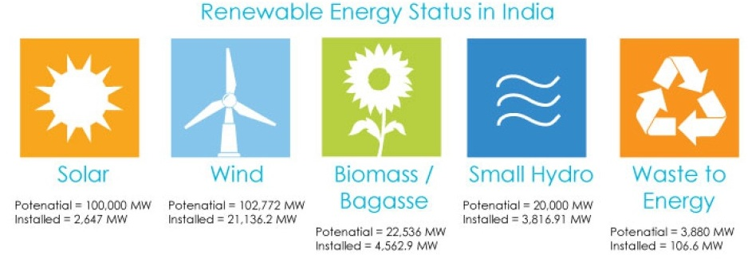

Solar Energy

India, being a tropical country, is blessed with abundant sunshine, 2,000 kilowatt hour/sq. metre (kWh/m²) per year for about 200–300 days in a year. The daily sunshine is between 5–7 kWh/m².

The solar energy, incident on earth in one week, is equivalent to the energy from the entire coal reserve of the world. Solar energy available on earth for 45 minutes is enough to meet our energy demand for one year.

However, the major problem is that sunlight is diffuse in nature.

Solar energy is ten times more expensive than thermal power because efficiency of conversion (light to electricity) is 18% only. Thermal power = heat energy converted into electrical power.
Photovoltaic cells (or) PV cells

- Solar cells consist of a p-type semiconductor (such as Si doped with B) and n-type semi-conductor (Si doped with P).

- They are in close contact with each other.

- When the solar rays fall on the top layer of p-type semi-conductor, the electrons from the valence band get promoted to the conduction band and cross the p-n junction into n-type semi-conductor

- There by potential difference between two layers is created, which causes flow of electrons (i.e. an electric current)

- Pnp semiconductor used

- Right diagram is important

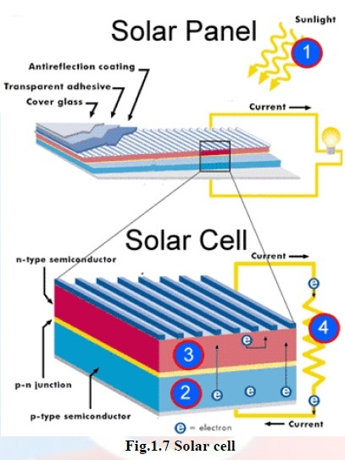

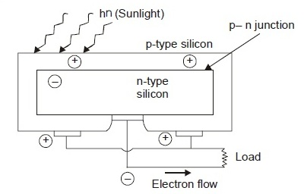

Solar heat collectors

Solar heat collectors consists of natural materials like stones, bricks, (or) materials like glass, which can absorb heat during the day time and release it slowly at night.

An average house with roof area about 1300 sq. ft. can get its energy supply for heating and hot water supply in December by this method.

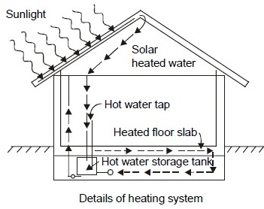

Wind Energy

Location where the wind velocity is at least 6.5 metres per second are suitable for installation of wind mills e.g. all along the coastline in India.

A standard wind mill produces 55 kilowatts of electricity daily.

The strike of blowing wind on the blades of the wind mill makes it rotating continuously. The rotational motion of the blade drives a number of machines like water pump, flour mills and electric generators.

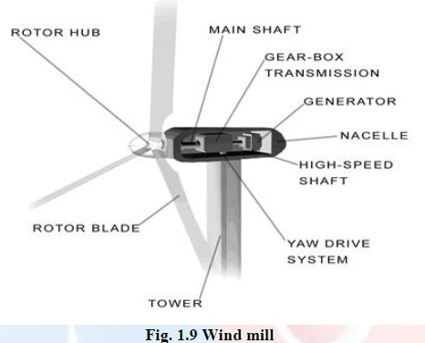

Ocean and Tidal Energy

Ocean waves splash on ocean shores at tremendous speed—the mechanical energy in this process can be harnessed and converted into electrical energy.

Each wave per 1 meter height can generate 90kW electricity whereas on the ocean shore the waves can generate 25–70 kW. During storm the generation level can rise up to 5 megawatts.

- The “high tide” and “low tide” refer to the rise and fall of water in the oceans.
- The tidal energy can be harnessed by constructing a tidal barrage.
- During high tide, the sea-water is allowed to flow into the reservoir of the barrage and rotates the turbine, which intern produces electricity by rotating the generators.
- During low tide, when the sea level is low, the sea water stored in the barrage reservoir is allowed to flow into the sea and again rotates the turbine.

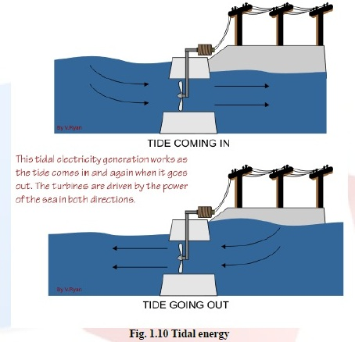

Geo-thermal Energy

- Temperature of the earth increases at a rate of 20 - 75⁰C per km, when we move down the earth surface.
- High temperature and high pressure steam fields exists below the earth’s surface in many places.
- The energy harnessed from the high temperature present inside the earth is called geothermal energy.
- When T>150 C at depth 2250 m.

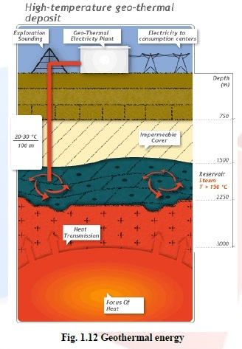

Biomass Energy

Biomass is an important energy source that contributes more than 14% of global energy supply. Bio-waste is burned to produce steam that turns a turbine to create electricity.

Biomass is the organic matter, produced by plants or animals, used as sources of energy.

Most of the biomass is burned directly for heating, cooling and industrial purposes.

In India, biomass provides fuel that accounts for about 32% of the total primary energy consumed and caters to almost 70% of the country’s population. It is widely available, renewable and carbon neutral.

e.g. Wood, crop residues, seeds, cattle dung, sewage, bagasse, rice husk, straw, cotton stalk, coconut shells, soya husk, de-oiled cakes, coffee waste, jute waste, groundnut shells and saw dust.

Biogas
- Mixture of methane, carbondioxide, hydrogen sulphide, ete.
- It contains about 65% of methane gas as a major constituent
- Biogas is obtained by the anaerobic fermentation of animal dung or plant wastes in the presence of water. (C₆H₁₂O₆ → 2 C₂H₅OH + 2 CO) Reactant is - Gluscose

Bio fuels
Biofuels are the fuels, obtained by the fermentation of biomass. e.g:

Ethanol
Ethanol can be easily produced from the sugarcane. Its calorific value is less when compared to petrol, and produces much less heat than petrol.
Methanol
Methanol can be easily obtained from ethanol or sugar-containing plants. Its calorific value is also too low when compared to gasoline and diesel.
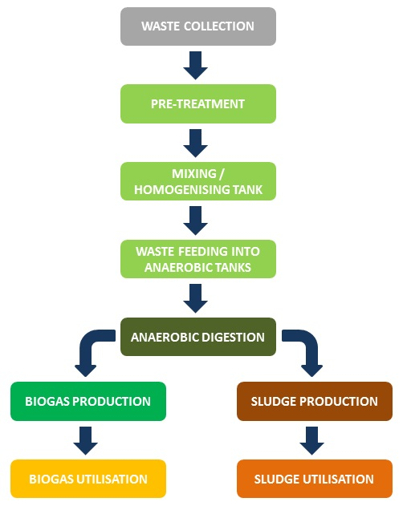
Biogas flow chart

Non-renewable energy resources
- Even our renewable resources can become non-renewable if we exploit them to such extent their rate of consumption exceeds their rate of regeneration.
- Wood is renewable resources because we can get new wood by growing sapling into a tree within 15-20 years.
- But the formation of coal from trees has taken million of years and cannot be regenerated in our life time.

Wood
Wood is most conventional and a major renewable natural resource.

In India 76 per cent of population lives in villages— majority of them use wood as fuel for cooking.

Interesting fact “In USA the Sunday issue of the leading newspaper, New York Times consisting of 500 pages requires 25 hectares of forest.”

Value of a tree

- Oxygen production (for 50 years)
- Control of soil erosion and soil fertility
- Recycling of water and control of humidity and atmospheric temperature
- Habitat for birds and other animals and insects, etc.
- Control of air and heat pollution

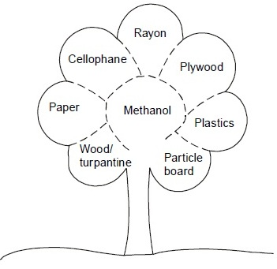
Hydroelectricity

The output from hydroelectricity accounts for 21 per cent of total electricity generation.

The merits of hydroelectricity are
- clean source of energy;
- no emission of greenhouse gases;
- no consumption of fuel;
- Simple technology.

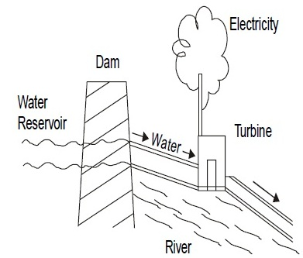

There are several environmental issues
- flora and fauna in the region are disturbed due to construction of dam;
- local people become refugees as they are uprooted from their houses;
- the capacity of the reservoir gets reduced due to siltation;
- Occurrence of floods in the area when surplus water has to be discharged in monsoon season.
- Coal

- Total coal reservoir is 7 × 10¹² metric tons which is equivalent to 5 × 10²² calories.

- The carbon content of Anthracite is 90% and its calorific value is 8700 k.cal.

- The carbon content of bituminous, lignite and peat are 80, 70 and 60% respectively

- India has about 5% of world’s coal. Indian coal is not good because of poor heat capacity.

- It is a dirty fuel. On combustion, it emits SO₂ which is an offensive gas and forms H₂SO₄ in air and causes acid rain in faraway places.

- Excavation of coal from mines is followed by soil subsidence (depression) which endangers the residential areas above the coal mines.

- Fly ash, arising from combustion of coal, is a nuisance as solid waste which brings about environmental problems.

- High grade ash-free coal is produced as solvent-refined coal (SRC) by suspending pulverized coal in a solvent and treating with 2 per cent of its weight of hydrogen at a pressure of 1000 pounds per sq. inch and 450° C. The product is a semi-solid, 170° C having a calorific value of 16,000 BTU per pound.

- BTU – British thermal unit

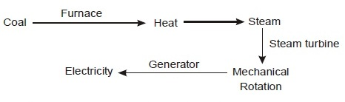
Petroleum

- Petroleum or crude oil = hydrocarbons +small amount S, O, N.
- The world reserve of petroleum is about 800 billion barrels (1 barrel = 31.5 gallons = 120 litres) which will last for less than 100 years.
- The fossil fuel formed by the decomposition of dead animals and plants that were buried under lake and ocean at high temperature and pressure for million years
- Hydrocarbons are separated by fractioning the crude oil.
- 180 degrees keroscene- jet fuel and 40 degrees petrol, 260 degrees diesel

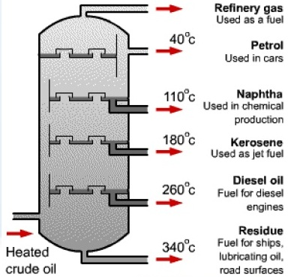

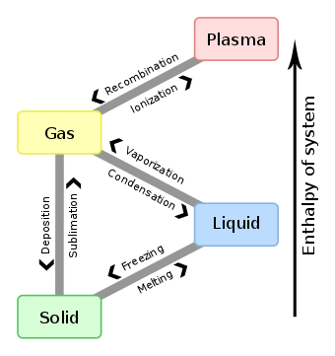

Nuclear energy

- It is also a clean energy but they release large quantities of radioactive fission products.
- 1 kg of Uranium–235 on a complete fission by slow neutrons releases energy equal to 1.7 × 10¹³ calories. This means energy-wise, 1 lb. of Uranium – 235 5 million lbs. of coal
- Nuclear fission reaction is used and large amount of energy is released.

92U²³⁵ +0n1 → 36Kr⁹² + 56Ba¹⁴¹ + 3 0n¹ + energy

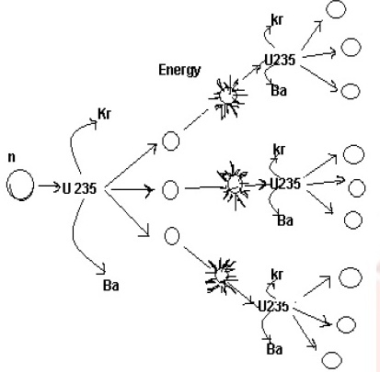

LAND RESOURCES

- It provides food, fibre, wood, medicine and other biological materials
- Soil is the mixture of inorganic materials (rocks and minerals) and organic materials (dead animals and plants).
- Top soil is classified as renewable resources.

LAND DEGRADATION

- Process of degradation of soil or loss of fertility of the soil.

CAUSES OF LAND DEGRADATION

- Population

- Urbanization

- Fertilizers and pesticides

- Damage of top soil

- Water-logging

- Soil erosion
Causes of soil erosion
- Water

- Sheet erosion

- Rill erosion

- Gully erosion

- Stream bank erosion

- Wind

- Saltation

- Suspension

- Surface creep

Control of soil erosion (or) soil conservation practices

- Conservational till farming (or) no-till-farming

- Contour farming

- Terracing

- Alley cropping (or) Agro forestry

- Wind breaks or shelter belts
Management and conservation of natural resources

Soil conservation practices
- Conservational till farming (or) no-till-farming
- Contour farming- across the slope
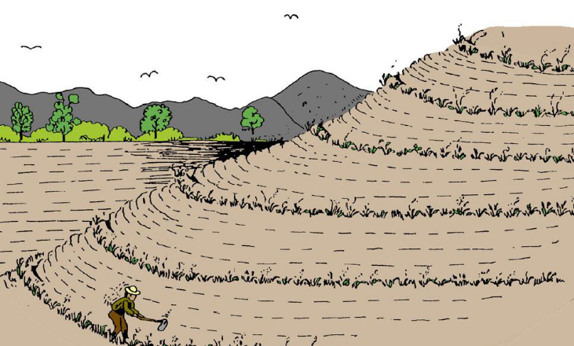

- Terracing

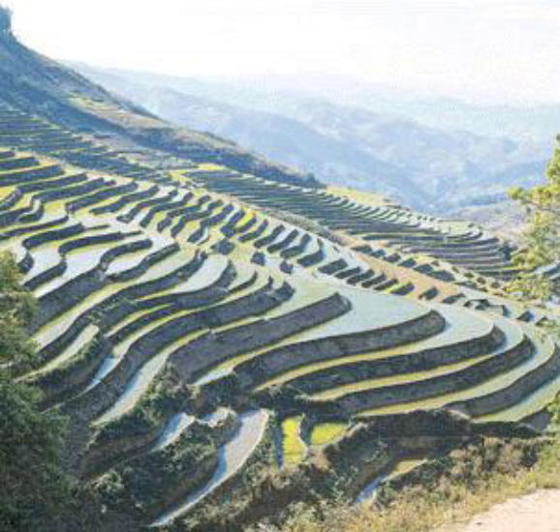

- Alley cropping (or) Agro forestry

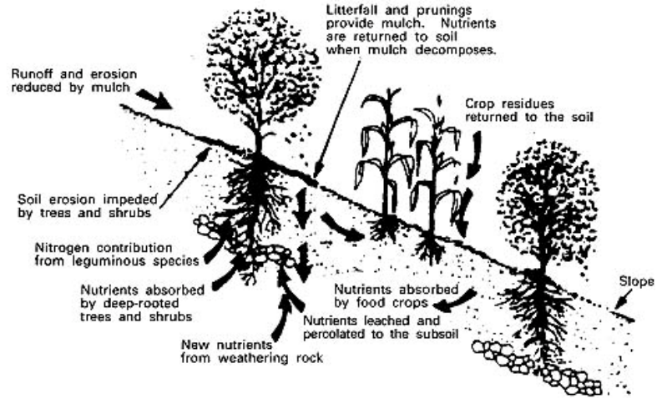

Alley Cropping is planting rows of trees at wide spacings with a companion crop grown in the alleyways between the rows.

- Wind breaks

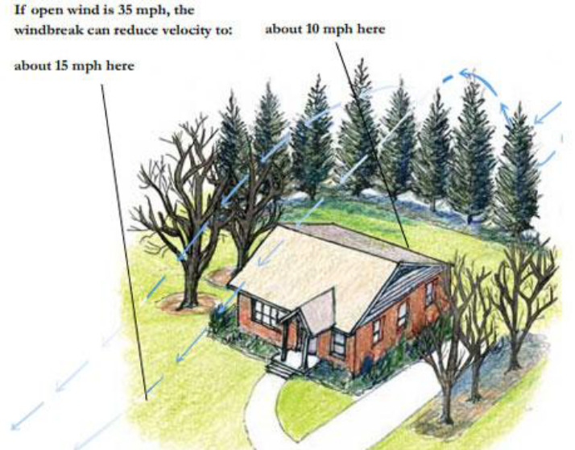

WATER RESOURCES
Fresh water- 2.4% . in that ground water is 12%

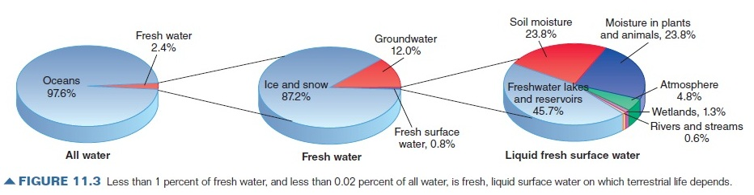

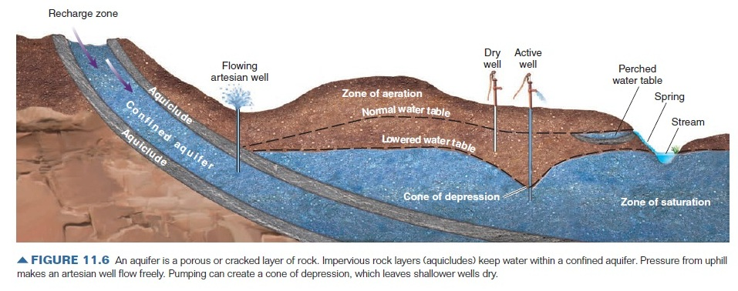
Groundwater Storage
Water (watershed) management

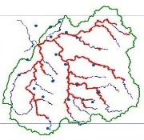

- Watershed approach - appropriate to solve various resources problems for planning, implementation and management.
- Managing Land & Water - Resources becomes a focal point in order to understand factors that contribute the problem.

- Tasks such as modeling, monitoring & reporting under watershed framework under watershed framework - saves time and money

- People’s participation - pillar of watershed approach gives sense of ownership; greater public involvement & ensures sustainability of interventions planned.

z
Watershed Complications
- Influence of human on watershed development
e.g. Changing contour of land & its use, pollution sources.
Remedies: Land management, Stop pollution at source; waste management, Reduce fertilizers.

- Water related issues: Surface & groundwater quantity & quality.
Remedies: change in cropping pattern, agricultural water management, rainwater harvesting, stopping point and nonpoint sources of pollution

Principles of Watershed Management
- Utilizes land according to capability
- Maintain adequate vegetative cover for control of soil erosion
- Conserve maximum possible rainwater at places where it falls
- Contour farming
- Drain out excess water with a safe velocity to avoid soil erosion and store it for future use
- Preventing erosion & to increase groundwater recharge
- Overall management of the available resources in a sustainable way

Conserve Water

- Use drip irrigation and sprinkling irrigation to improve irrigation efficiency and reduce evaporation.
- Install a small system to capture rain water and collect normally wasted used water from sinks, cloth-washers, bathtubs etc. which can be used for watering the plants
- Build rain water harvesting system.
WASTE WATER TREATMENT
Industrial Waste Water Treatment

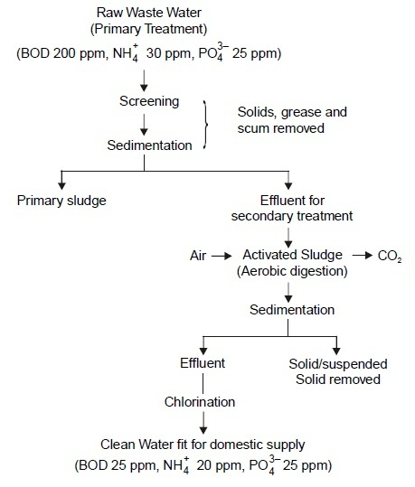

Domestic Waste Water Treatment

bacteria
Organic wastes + O₂ CO₂ (carbon dioxide)
(carbon, oxygen, + H₂O (Water)
hydrogen, sulphur, + NO₃ (nitrate)
fluorine) + NH₄ (ammonium ion)
Solid Waste Disposal
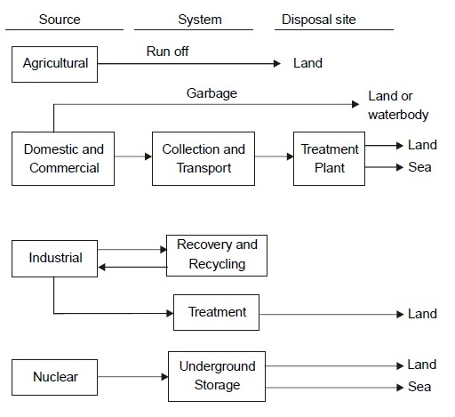

NON-HAZARDOUS WASTE MANAGEMENT

Two techniques are available—(i) Landfill and (ii) Incineration. Destruction of waste material by burning

- solid wastes should be deposited in a regulated manner, preferably in gravel pit;
- solid wastes should be spread in thin layers with ground cover of at least 15 cm;
- all factors likely to contribute to water pollution should be eliminated;

- the wastes should not be burnt openly.
Forest conservation

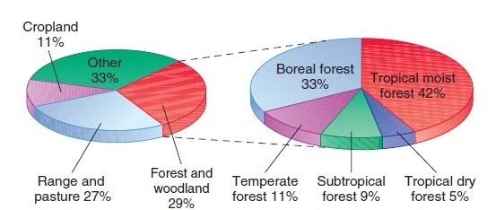

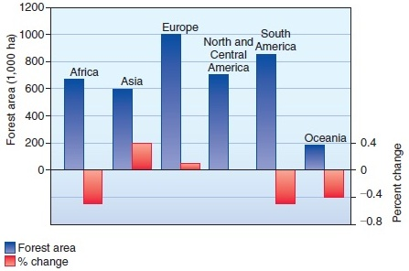
Forest status in India

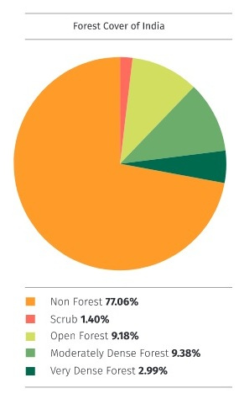

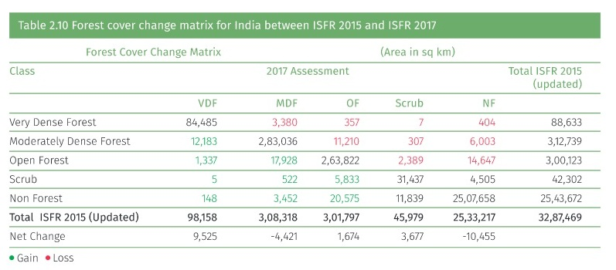

http://fsi.nic.in/isfr2017/isfr-forest-cover-2017.pdf - Forest Survey Report 2017
Carbon Stock in Indian Forests
5 carbon pools
Above ground biomass
Below ground biomass
Litter
Dead wood
Soil and organic carbon

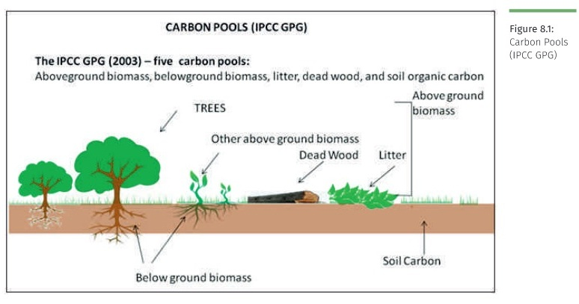

- In Forest ecosystem, enormous carbon is stored in five pools.

- The living portion of biomass carbon is classified in two pools – above ground biomass (AGB) and below ground biomass (BGB).

- Dead organic matter is classified in two pools – dead wood and litter.

- The fifth pool is soil organic matter (SOM).

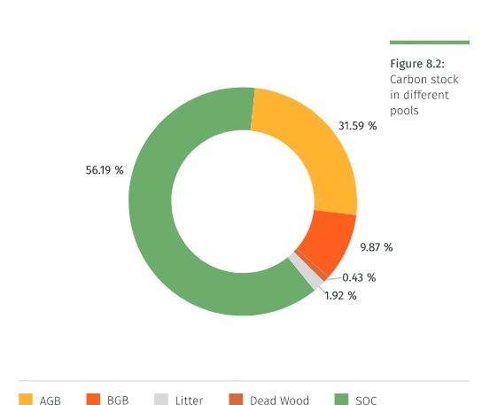

Maximum: Soil and organic C> AGB> BGB> Litter> Dead wood

- The largest remaining areas of old-growth forest are in Russia, Canada, Brazil, Indonesia, and Papua New Guinea. Together, these five countries account for more than three-quarters of all relatively undisturbed forests in the world.

- Ideally, forest management involves scientific planning for sustainable harvests, with particular attention paid to forest regeneration.

- Forest Protection - about 14 percent of all world forests are in some form of conservation status, but the effectiveness of that protection varies greatly. Costa Rica has one of the best plans in the world for forest guardianship.

- Forests are a huge carbon sink, storing some 422 billion metric tons of carbon in standing biomass. Clearing and burning of forests is responsible for about 17 percent of all the carbon released by human actions every year.

- Moisture released from forests affects rainfall not only locally, but sometimes far away. For example, recent climate studies suggest that deforestation of the Amazon could reduce precipitation in the American Midwest.


Members of the Surui tribe use computers
and smart phones to map, monitor, and
protect their ancestral lands in the Amazon rainforest.

Google Earth. Since its introduction in 2005,
This powerful application has become a
valuable tool for scientists, activists, and
ordinary citizens who want to better understand,
monitor, and communicate about the environment.

Earth Engine provides a dynamic digital
model of the whole planet that’s updated daily.

Draft Criteria for Sustainable Forestry

- Conservation of biological diversity
- Maintenance of productive capacity of forest ecosystems
- Maintenance of forest ecosystem health and vitality
- Maintenance of soil and water resources
- Maintenance of forest contribution to global carbon cycles
- Maintenance and enhancement of long-term socioeconomic benefits to meet the needs of legal, institutional, and economic framework for forest conservation and sustainable management

Ecosystem Management
- Manage across whole landscapes, watersheds, or regions over ecological time scales.
- Depend on scientifically sound, ecologically credible data for decision making.
- Consider human needs and promote sustainable economic development and communities.
- Maintain biological diversity and essential ecosystem processes.
- Utilize cooperative institutional arrangements.
- Generate meaningful stakeholder and public involvement and facilitate collective decision making.
- Adapt management over time, based on conscious experimentation and routine monitoring.
How do deforestation and degradation release carbon?

- Trees are burned, releasing carbon (C) stored in wood and leaves.
- Fallen vegetation decays, releasing stored C.
- Accumulation of C in soil litter declines; exposed soils dry, and C in soil oxidizes to CO₂.
- The forest ecosystem is no longer available to store C.

What drives deforestation?

- Industrial-scale agriculture (soy and palm oil production, cattle ranching)
- Industrial logging driven by international demand for timber
- Poverty and population pressure as people seek farmland and fuelwood
- Road development, oil development, mining, and dams

